LAB 3 Report - ECSE 403

Mohamed Reda EL KHILI - 260678513

François-Eliott Rousseau - 260670000

Ismail Faruk - 260663521

**4.1 Linearity of the System**

1. We implemented the following Matlab script to get the plot:

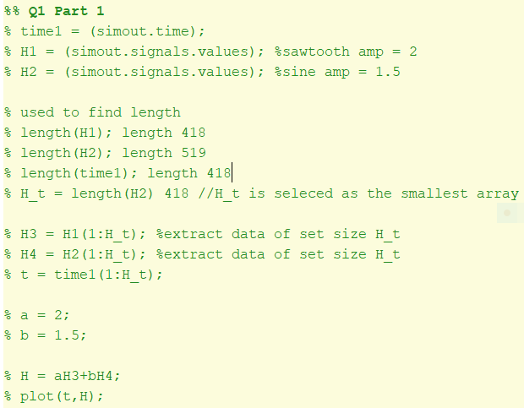

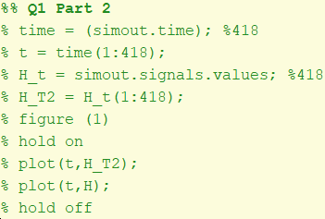

Figure 1: Matlab code to export Simulink data and superimposing the graphs

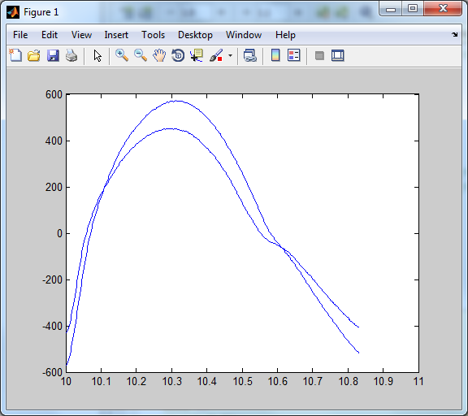

Figure 2: Sum of response and Sum of inputs, superimposed

The graph with the higher peak is for aH{x1(t)}+bH{x2(t)}.

The graph with the lower peak is for H{ax1(t)+bx2(t)}

We can observe that both response of the system look pretty similar. We can therefore say that these signals are linear.

2. System with sine wave as input:

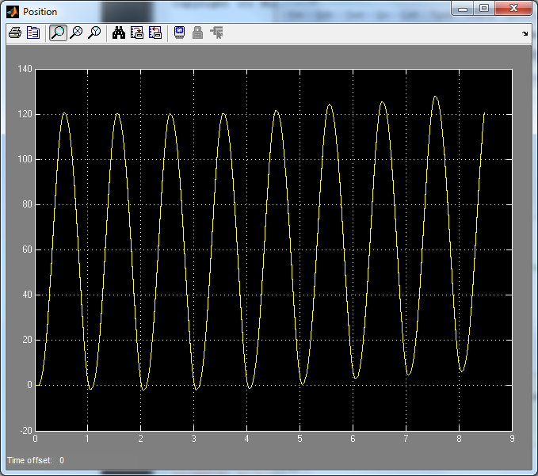

Figure 3: Response to input as a sine wave

We can confirm that the system is LTI because the signal has the same amplitude and is occurring at a fix period of time (same frequency). We can say that this signal is periodic despite the minor shift of the signal on the y axis. It is therefore time invariant and linear.

3. We would disagree with that person because the divergence from practical measurements and theoretical measurements is not due to a hidden feedback loop. Indeed, any kind of feedback loop doesn’t affect linearity, therefore the range of error between measurements. The divergence may be cause by friction, noise or human error while manipulating the equipment.

4. Possible sources of non-linearity of the system are the nonlinear spring restoring force Fsp and static also called Coulomb friction (in mechanical system). We also have A/D and D/A which also a possible source of non-linearity.

**4.2 System Identification**

1. Transfer function:

$\frac{x (cm)}{V(Volts)} =\frac{1}{(m_{c}r_{g}/K_{m}K_{g}) * s^{2} +(K_{e}K_{g}/r_{g})*s}$

$\frac{v (cm/s)}{V(Volts)} =\frac{1}{(m_{c}r_{g}/K_{m}K_{g}) * s +(K_{e}K_{g}/r_{g})}$

2. $\frac{v (cm/s)}{V(Volts)} =\frac{1}{(0.526*0.0064/K_{m}) * s +(K_{e}/0.0064)}$

3.

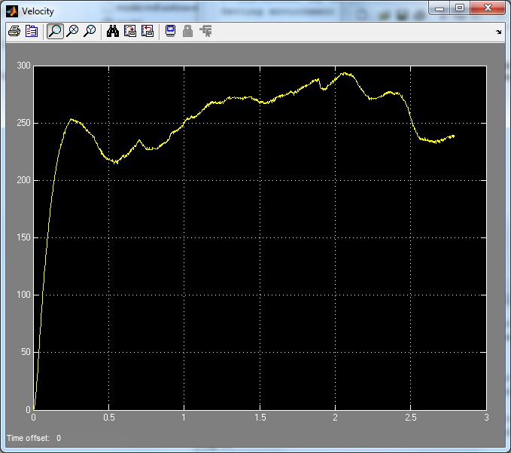

Figure: Step Response of the system

4. We found a gain of 140 mm/sec/V and a time constant of 0.1167.

We know that for any transfer function G(S), we have:

$G(S)=\frac{K}{τs+1}$ where K is the gain and τ is the time constant.

Hence, we have $G(S)=\frac{140}{0.1167s + 1}=\frac{1200}{s + 8.569}$

5.

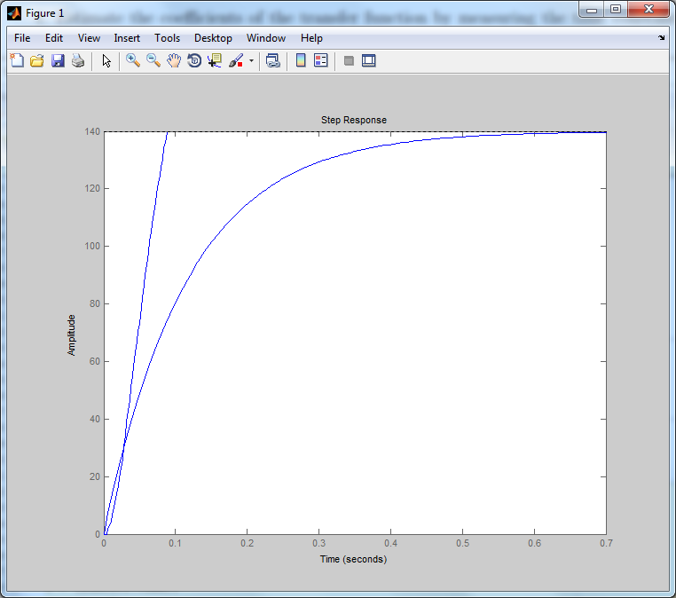

Figure: Estimated and actual step responses

6. As we can see in the previous plot, our estimated step response has a shape similar to our actual step response. Nevertheless, we can see that it takes more time than the theoretical step response to reach its steady state value. The main reasons for this difference is that we are plotting the step response based on observed and measured values for the coefficients of the transfer function which make them less accurate than theoretical values. Moreover, these coefficients are measured based on the cart system which takes digital input data and turn it into analog data which also is a source of noise and inaccuracy.

7.

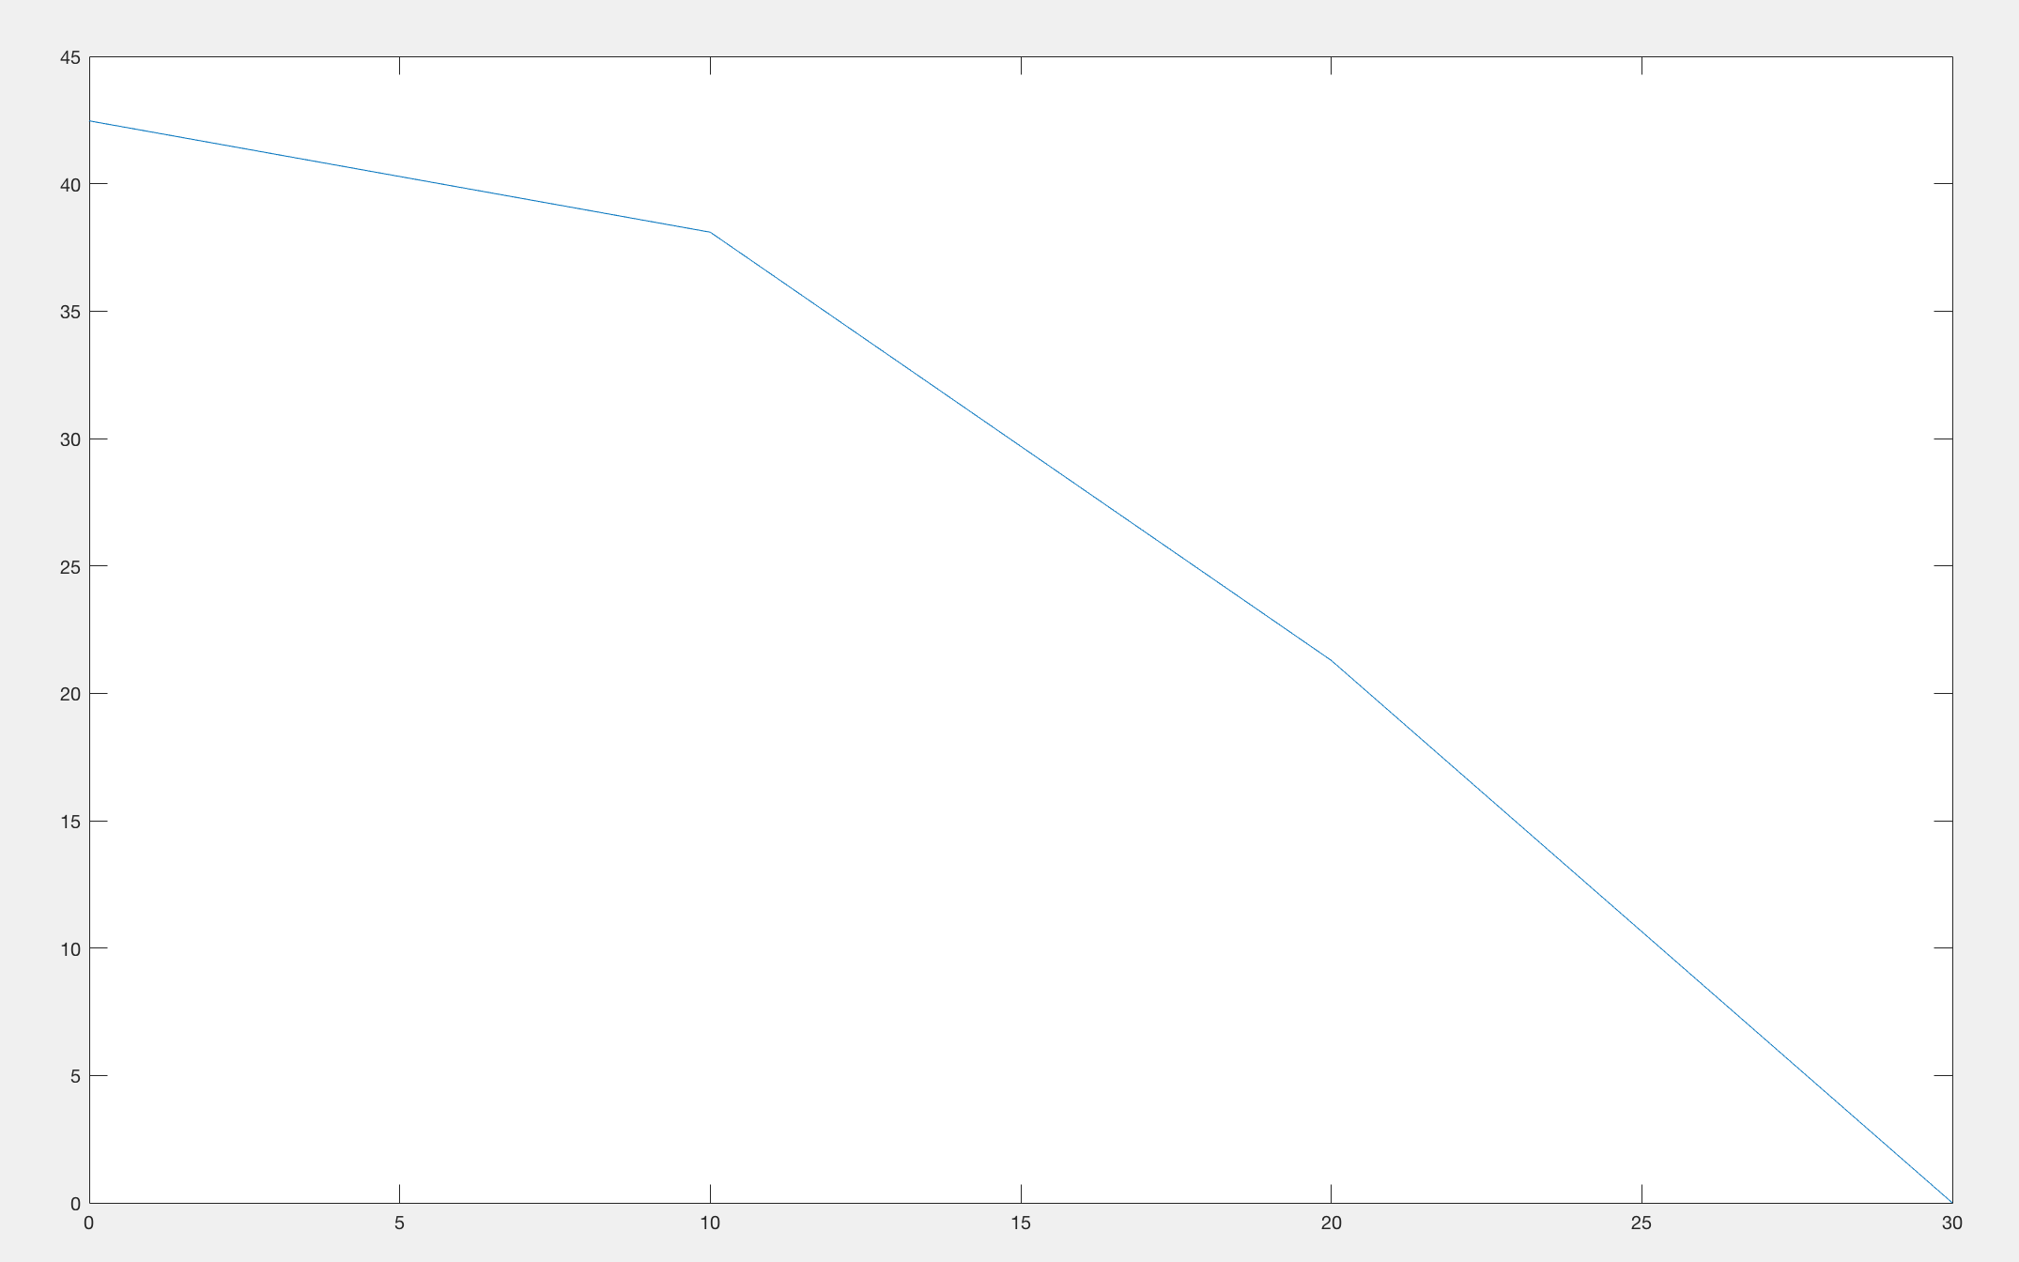

Figure: Bode plot from experiment

8.

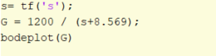

Figure: Matlab script for transfer function and Bodeplot

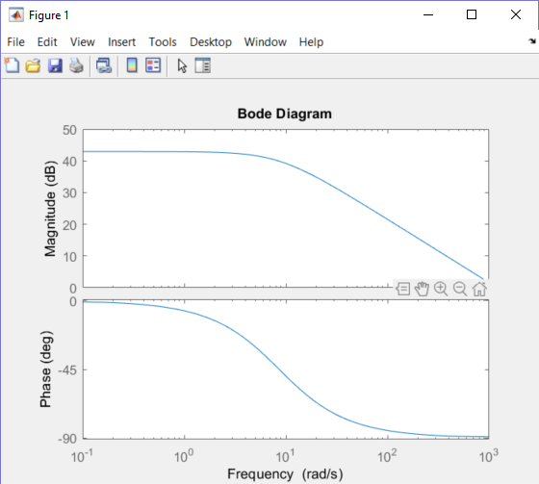

Figure: Bode plot from Matlab

9.

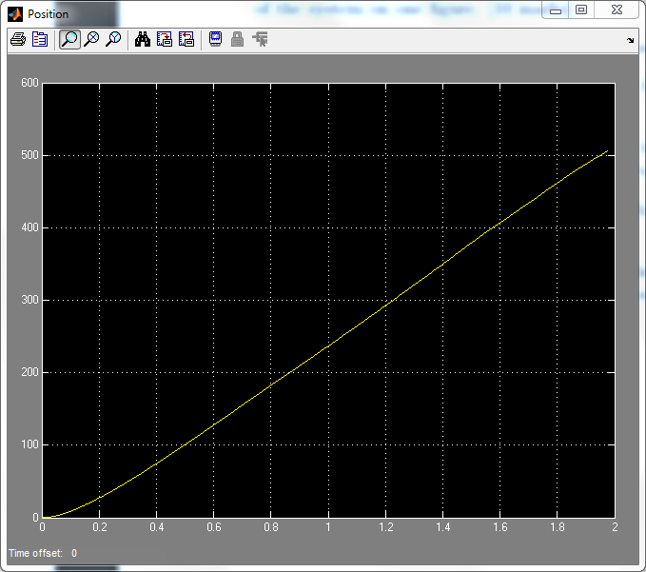

Figure: Step response of the system with position as output

10.

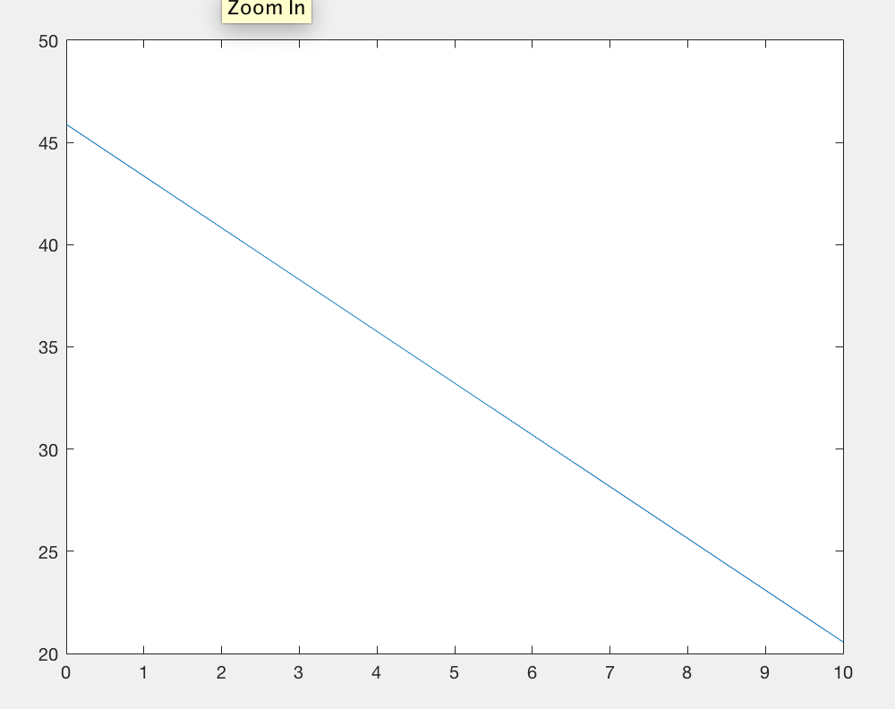

Figure: Experimental Bode Plot